# Unit 2: Atomic Structure and Bonding

# <H1>Essential Questions

* 1. How does the organization of elements in the periodic table help us predict their properties?
  2. How do atoms combine to make all the different compounds that exist?

## <H1>**Unit Big Idea: The Unseen World of Atoms**

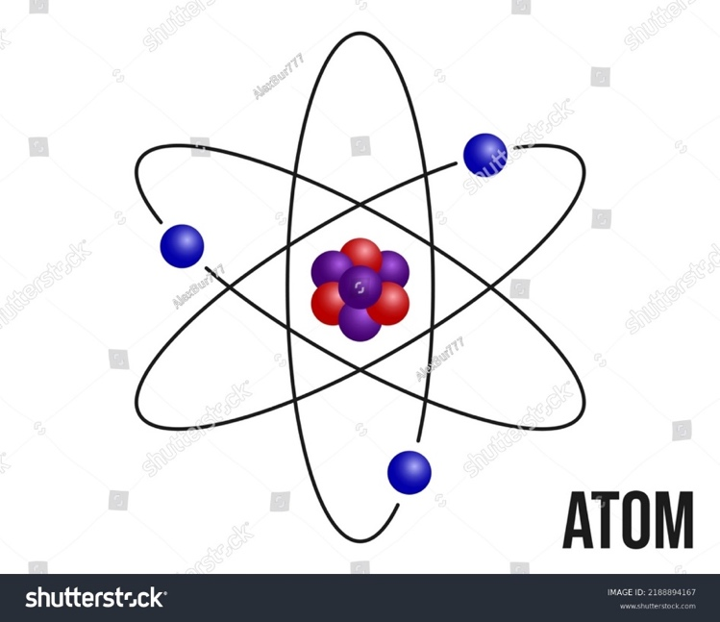Atoms are the fundamental building blocks of the matter we can see, invisible yet omnipresent. By unlocking the mysteries of atomic structure and bonding, we delve into the nature of everything around us. Understanding atomic models, electron configurations, and bonding theories reveals the patterns that govern chemical interactions and offers insights into the structure and behavior of matter itself. The periodic table is like a map guiding us through the intricate and beautiful dance of elements.

Fig. U2.1 An Atom

# <H1>Unit Marvel: Danger! Icy Roads

In northern countries, where winter brings extremely cold weather, streets and roads are often covered in ice and snow. This creates hazardous conditions for both pedestrians and drivers. Pedestrians can slip and fall, risking injury, while cars may skid on the icy surfaces, potentially causing accidents. To reduce these dangers, road salt is spread on streets to help melt the ice and snow. As the salt comes into contact with the ice and snow, they melt. On street signs and lampposts, which are not salted, the ice and snow do not melt.

# <H1>Last Time, This Time, Next Time

|  |  |
| --- | --- |
| Last time | Everything in the universe is composed of tiny particles called atoms.  Atoms are responsible for the physical and chemical properties of all objects.  Atoms have mass and are electrically neutral. |
| This time | The protons and neutrons of the atom’s nucleus are mostly responsible for the atom’s mass.  Protons have a positive charge while neutrons have no charge.  The atom’s negative charge resides in the electrons, located outside of the nucleus in energy levels or orbits.  The elements are organized in a Periodic Table to highlight properties and trends.  Atoms can lose or gain electrons. When this happens, atoms are no longer neutral and are called ions.  Atoms that have lost electrons to become ions with positive charge are called cations.  Atoms that have gained electrons to become ions with negative charge are called anions.  Since opposite charges attract, cations and anions strongly attract each other and form a bond called ionic bond.  Atoms can also combine by sharing electrons in other types of chemical bonds.  In covalent bonds, electrons are usually shared and localized between two atoms. In covalent bonds, electrons are typically shared between two atoms and may be localized or delocalized, depending on the molecular structure.  In metallic bonds, electrons are shared and delocalized among a network of positively charged metal ions. |
| Next time | Substances react in different ways forming other substances.  Substances react in different proportions to form different substances. |

# <H1>Unit Stem Task

Explain how the atomic structure impacts chemical bonding and influences the properties of substances we encounter in daily life, such as water as a solvent, salt dissolving in water, or metal not dissolving in water.

# <H1>Unit Overview

|  |  |
| --- | --- |
| **Chapters** | **PE** |
| Chapter 3: Unlocking the Atom | HS-PS1-1, HS-PS1-8 |
| Chapter 4: Electrons in Action | HS-PS1-1, HS-PS4-3 |
| Chapter 5: The Periodic Table and Chemical Trends | HS-PS1-1 |
| Chapter 6: Ionic and Metallic Bonding | HS-PS1-2, HS-PS1-3 |
| Chapter 7: Covalent Bonding | HS-PS1-2, HS-PS1-3, HS-PS1-4 |

# **Unit Wrap-Up**

# <H1> Summary of the Unit

## **Chapter 3: Unlocking the Atom**

## This chapter introduces the concepts essential for understanding the structure of atoms. It emphasizes the definition of subatomic particles, formation of atomic models, determination of the atomic number, mass number, properties, and uses of isotopes. **Lesson 1** explains the evolution of atomic models and structures proposed by various scientists. Further discussion on how these models and structures were improved over the page of time has also been explained in the lesson. The chapter discusses how these models evolved over time, incorporating improvements based on new discoveries. It also focuses on protons, neutrons, and electrons. In **Lesson 2**, the concepts of atomic number and mass number and the roles of subatomic particles in determining them are explained. **Lesson 3** addresses and explains isotopes and their applications. It explains the formula for calculating the atomic mass of various atoms by considering their isotopes.

**Chapter 4: Electrons in Action**

**Lesson 1**: This lesson introduces electron configuration and quantum numbers, explaining their role in describing the arrangement and energy of electrons in atoms. **Lesson 2**: This lesson explores the electromagnetic spectrum and the concept of quantized energy, detailing how energy levels relate to electron transitions and the emission of light. emphasizing how electron transitions relate to the emission of light. **Lesson 3**: This lesson covers the Bohr model and its explanation of atomic spectra, focusing on how energy levels produce unique spectral lines for each element.

C**hapter 5: The Periodic Table and Chemical Trends**

**Lesson 1**: This lesson traces the historical evolution of the periodic table and focuses on key contributions and the rationale for arranging elements according to their atomic numbers and properties**. Lesson 2**: This lesson explains how elements are organized into groups and periods based on shared characteristics, helping to understand their chemical behavior and classification as metals, nonmetals, or metalloids. **Lesson 3**: Periodic Trends and Predicting Properties of Elements – This lesson examines the trends such as atomic size radius, ionization energy, electron affinity, and electronegativity across the periodic table and emphasizes how these patterns help to predict the properties and reactivity of the element.

**Chapter 6: Ionic and Metallic Bonding**

## This chapter introduces the concepts of the formation of ions and ionic bonding, as well as metallic bonding and characteristics. It emphasizes the definition, types of ions, octet rule, ionic and metallic bonding, and properties of ionic compounds. **Lesson 1** explains the definition of ions, their properties, and how these ions are formed. L**esson 2** focuses on ionic bonding and compound formation and explains the effect of attraction forces with varying strengths on the properties of ionic compounds. **Lesson 3** addresses and explains the concepts and rules of naming and formulas of compounds**. Lesson 4** emphasizes metallic bonding and the characteristics of metals. In the four lessons, it is explicitly explaining how ionic bonding involves in the electrons transfer between atoms, whereas metallic bonding involves 'sea' of moving electrons are shared among the network structure of metal ions.

## **Chapter 7: Covalent Bonding**

This chapter explains the concept of covalent bonding, formation, and properties of covalent compounds. **Lesson 1** explains the definition of a covalent bond and how covalent compounds are formed, and it outlines the properties of covalent compounds. L**esson 2** focuses on and explains the concept and rules of naming and formulas of compounds**. Lesson 3**: This lesson explains the Valence Shell Electron Pair Repulsion (VSEPR) theory, which predicts molecular shapes in the presence of electron pair repulsion, helping to determine the geometry of molecules. **Lesson 4**: This lesson examines how electronegativity differences influence bond polarity and explores the types of intermolecular forces, such as dipole–dipole interactions and hydrogen bonding, that affect molecular behavior.

## **Mini-Index of Terms**

* **ionic bond**: a type of chemical bond formed by the electrostatic attraction force between a cation and an anion
* **lattice Energy**: the energy released when an ionic compound is formed from its constituent ions in the gaseous state
* **octet Rule**: atoms are most stable when they have eight electrons in their outermost shell
* **anion**: a negatively charged ion formed when an atom gains its valence electrons
* **cation**: a positively charged ion formed when an atom loses its valence electrons
* **electron Affinity**: the phenomenon of gaining an electron due to the presence of an effective nuclear charge of the element
* **ionic Radius**: the half of the diameter of the size of an ion compared to the size of its parent atom
* **ionization:** the process consists of gaining or losing electrons of an atom to become an ion the process by which an atom gains or loses electrons to form an ion
* **criss-cross method:** a technique used to write the formula of an ionic compound by cross-multiplying the charges of the ions to balance them
* **polyatomic ions:** ions that consist of more than one atom but behave as a single unit with a charge
* **boiling point**: the temperature at which a substance changes from liquid to gas
* **conductivity**: the ability of a material to allow electricity to pass through it
* **ductility**: the ability of a material to be stretched into thin wires
* **luster**: the shiny appearance of metals
* **malleability**: the ability of a material to be hammered or rolled into shapes without breaking
* **melting point**: the temperature at which a solid becomes a liquid
* **metallic lattice**: the organized structure formed by metal atoms, where positive ions are surrounded by a sea of electrons
* **sea of electrons**: a model describes how electrons are shared freely among metal atoms, allowing metals to conduct electricity
* **valence electrons**: the outermost electrons of an atom, which are involved in bonding
* **aufbau principle**: states that electrons fill orbitals starting from the lowest energy level before moving to higher ones
* **electron configuration:** the arrangement of electrons in an atom's orbitals, which influences its chemical properties
* **hund's rule:** electrons fill each orbital singly before pairing in orbitals of the same energy level
* **orbital:** a region around an atom's nucleus where electrons are most likely found
* **pauli exclusion principle:** each orbital can hold a maximum of two electrons with opposite spins
* **subshell (s, p, d, f):** divisions within electron shells that describe the shape and energy of orbitals
* **quantum numbers (n, l, ml, ms):** a set of four numbers that specify the position and properties of an electron in an atom
* **electromagnetic spectrum:** the range of all types of electromagnetic radiation, from radio waves to gamma rays
* **gamma rays:** high-energy radiation with short wavelengths, often used in medical imaging and cancer treatment
* **frequency:** the number of waves passing a point per second, influencing radiation energy
* **infrared radiation:** part of the spectrum felt as heat, often used in thermal imaging
* **microwaves:** radiation with longer wavelengths than infrared, commonly used in cooking
* **radio waves:** low-energy waves with the longest wavelength, used in communication
* **ultraviolet light:** radiation with higher energy than visible light, responsible for causing sunburn
* **visible light:** the portion of the spectrum detectable by human eyes, containing all the colors
* **wavelength:** the distance between successive wave crests, inversely related to energy
* **x-rays:** high-energy waves that can pass through soft tissue, used in medical imaging
* **absorption spectra:** a spectrum showing dark lines where light is absorbed, indicating at this energy level, electrons jump to the high energy level
* **emission spectra:** a spectrum is a collective form of wavelengths of light that are emitted from chemical compounds or when electrons transition from higher to lower energy states takes place represented as line depicts different wavelength of light appears on the spectrum
* **energy level:** a specific distance from the nucleus where an electron can be located, associated with a fixed energy
* **photons:** particles of light emitted when electrons transition go down between energy levels
* **transition:** the movement of an electron between energy levels, releasing or absorbing energy
* **atomic mass:** the weighted average mass of an atom of the element, considering the different isotopes and their abundance
* **atomic weight:** often used interchangeably with atomic mass, though it typically refers to the average mass of atoms of an element, expressed in atomic mass units (u)
* **modern periodic table:** the arrangement of elements by increasing atomic number, reflecting their properties and reactivity patterns
* **lewis dot structure:** a diagram showing an element's symbol surrounded by dots representing its valence electrons, useful for visualizing bonding
* **groups and periods:** groups are vertical columns in the periodic table where elements have similar properties, and periods are horizontal rows where properties gradually change
* **metals:** elements, typically on the left side of the periodic table, characterized by high conductivity, malleability, and the tendency to lose electrons
* **metalloids:** elements with properties between metals and nonmetals located along the “staircase” line on the periodic table
* **nonmetals:** elements generally found on the right side of the periodic table; they tend to gain or share electrons and are often insulators
* **valence electrons:** electrons in the outermost shell of an atom that determine its bonding behavior and chemical reactivity
* **atomic trends:** regular patterns or variations in element properties (e.g., atomic size, ionization energy) across the periodic table
* **atomic radius:** the average distance from the nucleus to the outermost electron, indicating the size of an atom
* **electron affinity:** the amount of energy released when an isolated gaseous atom gains an electron, reflecting its tendency to accept electrons
* **electronegativity:** a measure of an atom's ability to attract electrons in a chemical bond, influencing molecule polarity
* **ionization energy:** the energy required to remove an electron from an isolated gaseous, indicating its reactivity and ability to form cations
* **bond angle:** the angle formed between three atoms across at least two bonds, determining molecular shape
* **electron pair repulsion:** the principle that electron pairs around a central atom repel each other and arrange themselves to minimize this repulsion
* **lone pair:** a pair of valence electrons not involved in bonding, which affects molecular geometry
* **molecular geometry:** the three-dimensional arrangement of atoms in a molecule, influenced by electron pairs and bonding atoms
* **tetrahedral:** a molecular shape where a central atom is bonded to four atoms at the corners of a tetrahedron, with bond angles of about 109.5°
* **trigonal planar:** a molecular shape with a central atom bonded to three atoms in a plane, with bond angles of about 120°
* **vsepr theory:** valence shell electron pair repulsion theory, used to predict molecular shapes based on electron pair repulsions around a central atom
* **boiling point:** the temperature at which a liquid becomes a gas, affected by intermolecular forces
* **dipole-dipole forces:** attractions between polar molecules, where partial charges on one molecule attract opposite charges on another
* **dipole moment:** a measure of the polarity of a molecule with a positive and a negative pole
* **hydrogen bonding:** a strong intermolecular force occurs when hydrogen is bonded to a highly electronegative atom, significantly impacting properties like boiling point and viscosity
* **intermolecular forces:** forces of attraction or repulsion between molecules, influencing their physical properties
* **london dispersion forces:** weak, temporary forces due to momentary electron distributions, present in all molecules but dominant in nonpolar ones
* **melting point:** the temperature at which a solid turns into a liquid, impacted by the strength of intermolecular forces
* **polarity:** the distribution of electrical charge over atoms in a molecule, leading to positive and negative regions
* **solubility:** the ability of a substance to dissolve in a solvent, often dependent on polarity
* **viscosity**: a measure of a fluid's resistance to flow, influenced by intermolecular attractions

**Key Images**

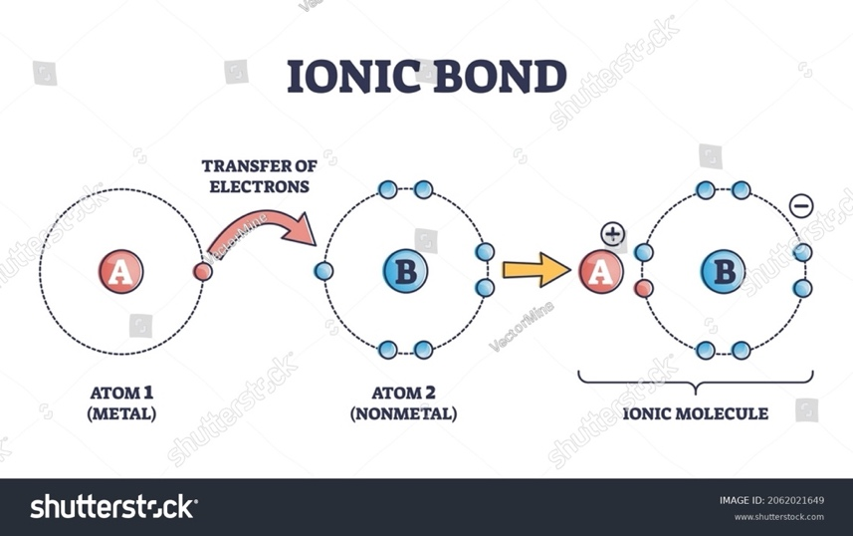

**Ionic Bond**: Image illustrating the formation of ionic bonds by the transfer of electrons from one atom to another.

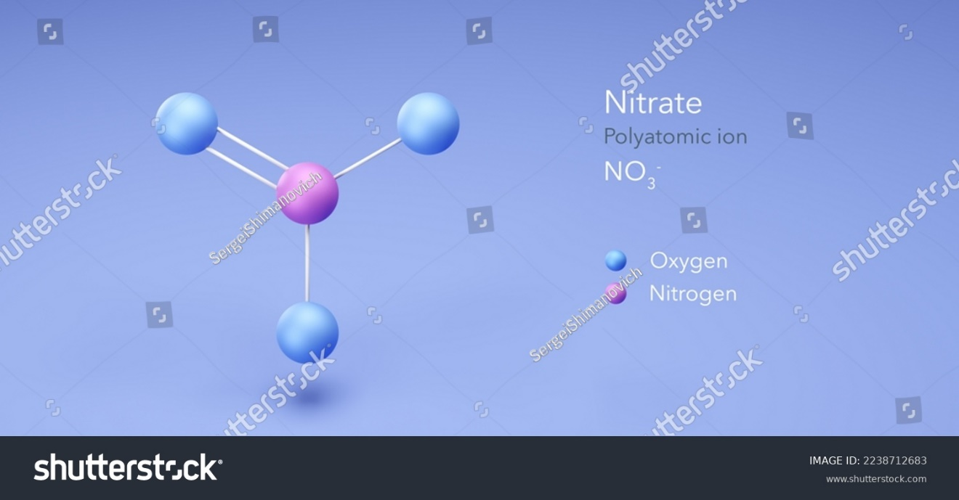

**Polyatomic Ion:** Image showing an example of a polyatomic ion that consists of more than one atom but behaves as a single unit with a charge.

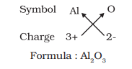

**Crisscross Method:** The illustration showing a technique is generally used to write the formula of an ionic compound by crisscrossing the charges of the ions to balance them.

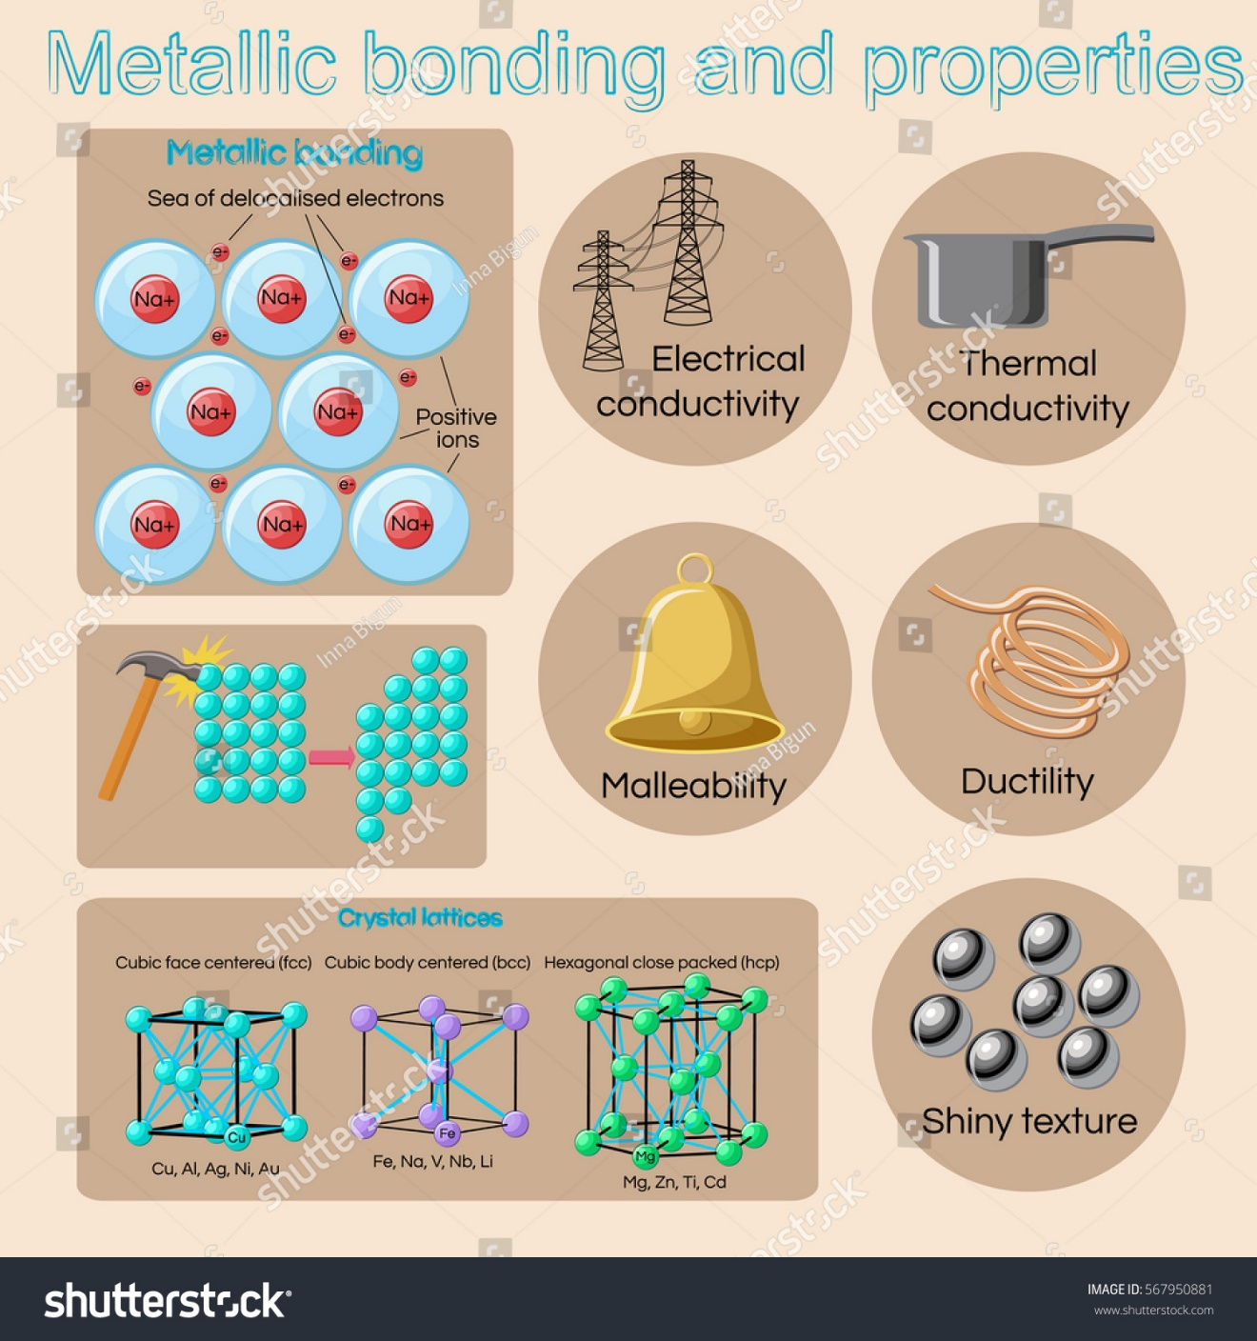

**Characteristics of Metals:** Visual representation shows the various characteristics of metals

Figure: Metallic bonding.

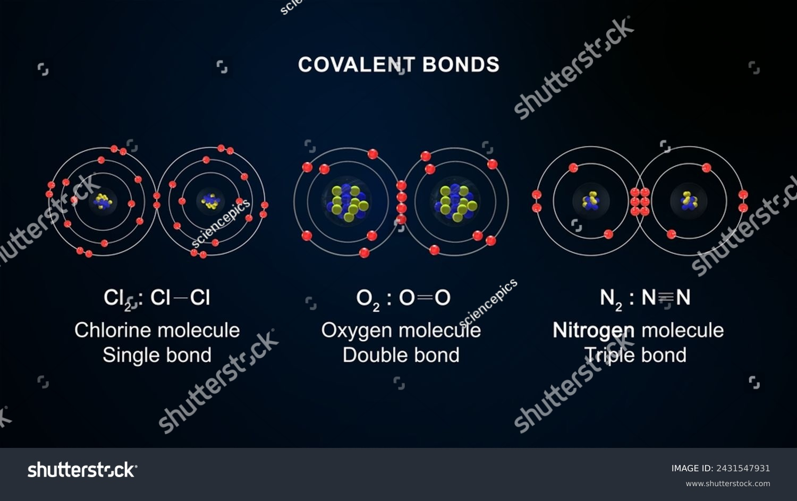

**Types of Covalent Bonding**: Visual representation showing the types of bonds formed by the covalent compounds by mutual sharing of electrons

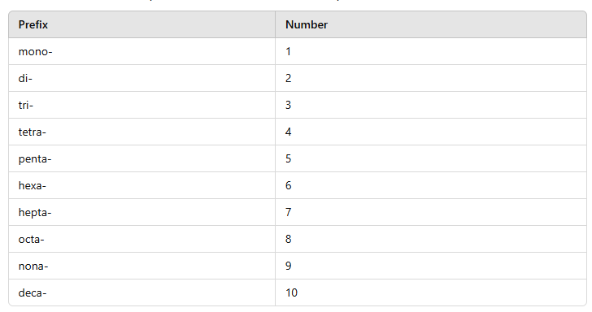

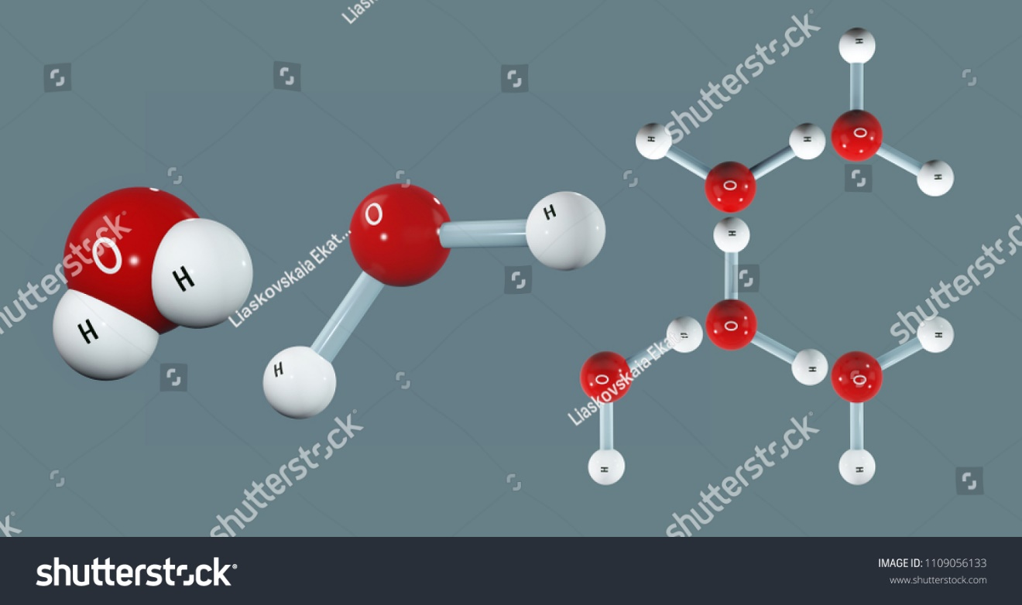

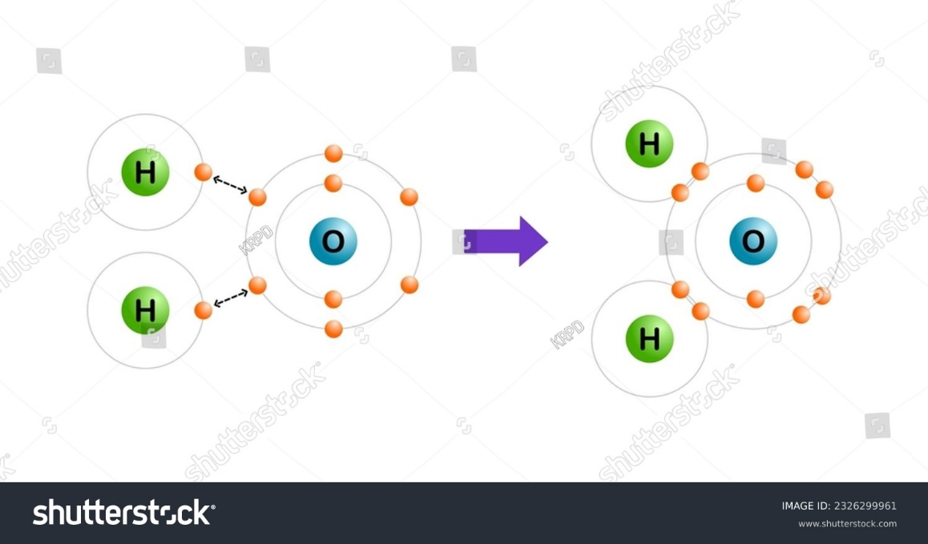

Visual representation of a covalent bond in water formed by the sharing of electrons in water.

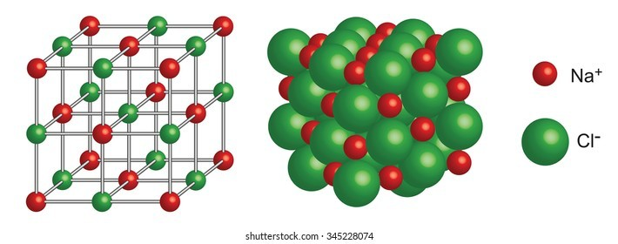

## 

Visual representation of crystal lattice formed by the combination of an anion and a cation.

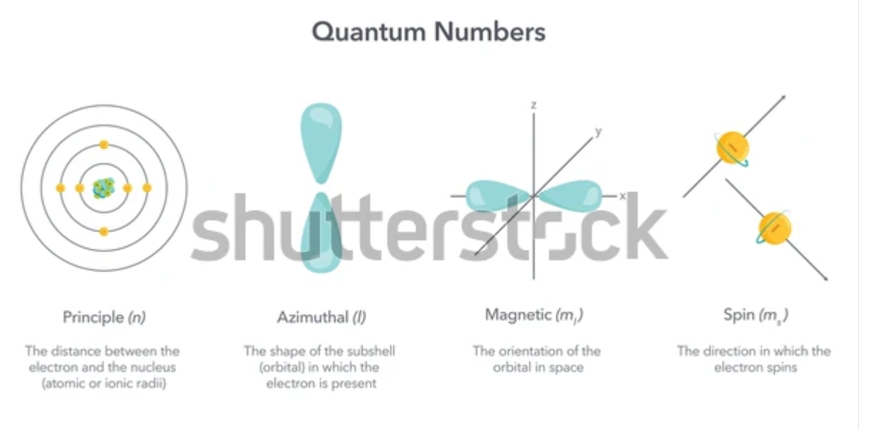

**Quantum Numbers Visualization:** Image illustrating the four quantum numbers (n for principle

quantum number, l for azimuthal, ml for magnetic, ms for spin only), detailing the unique position and behavior of each electron.

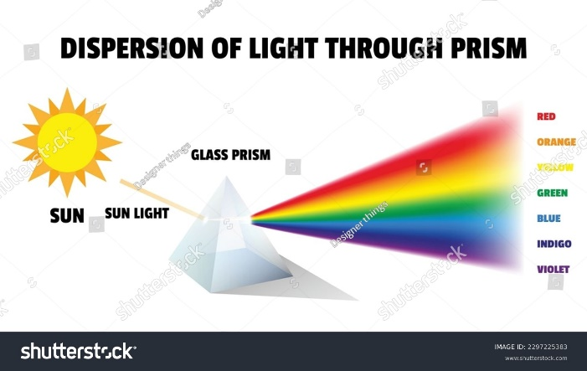

**Light Dispersion Through a Prism:** Demonstrates visible light splitting into a rainbow, illustrating the range of visible wavelengths in the electromagnetic spectrum.

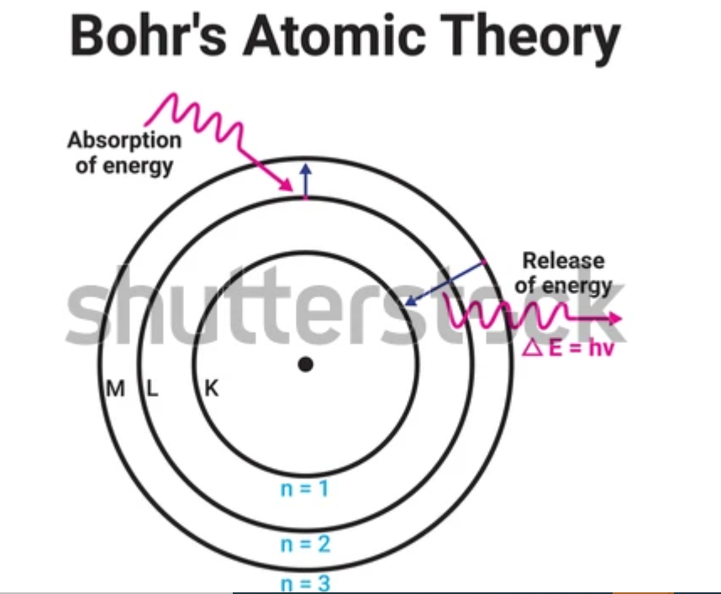

**Bohr Model of the Atom:** Visual representation of electrons orbiting the nucleus in fixed energy levels, illustrating electron transitions and the emission of light.

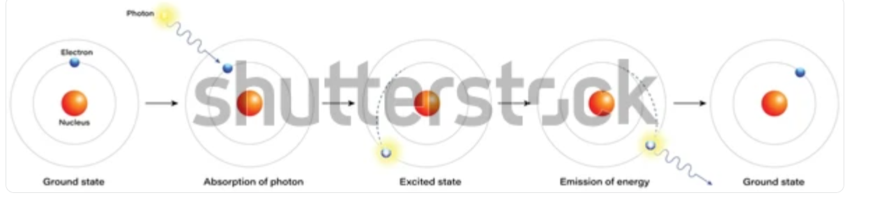

**Energy Transition and Photon Emission:** Diagram illustrating electron transitions between energy levels and associated photon emission, which produces atomic spectra.

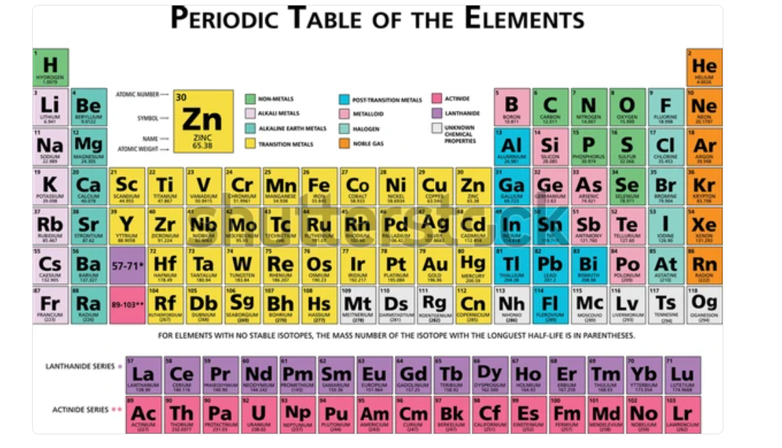

**Modern Periodic Table:** Updated table arranged by atomic number, reflecting corrected placements based on atomic structure.

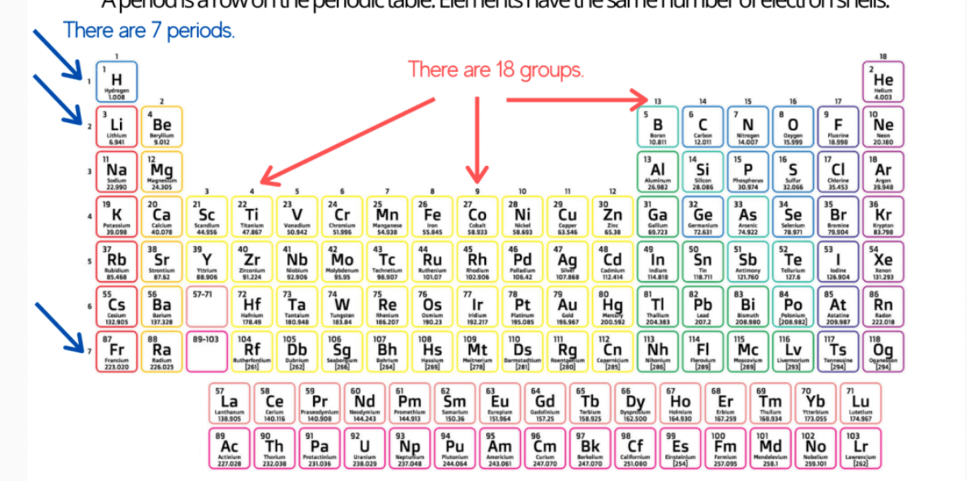

**Groups and Periods of the Periodic Table:** Illustration marking groups (columns) and periods (rows), showing the classification of elements as metals, metalloids, and nonmetals.

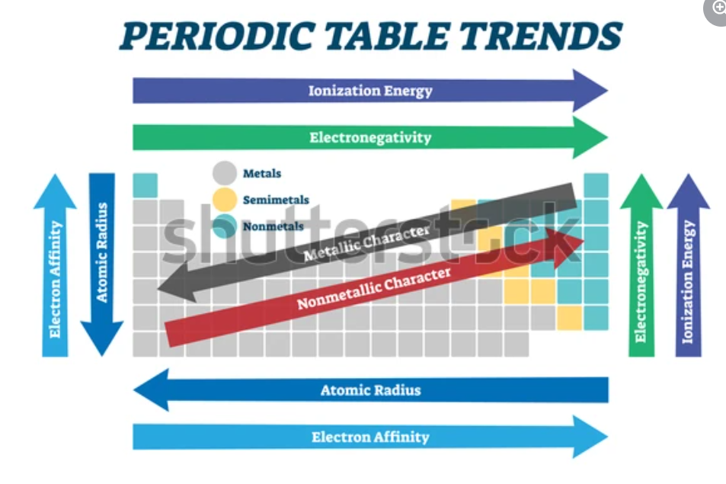

**Periodic Table with Periodic Trends:** A labeled periodic table showing trends in atomic radius, ionization energy, electron affinity, and electronegativity.

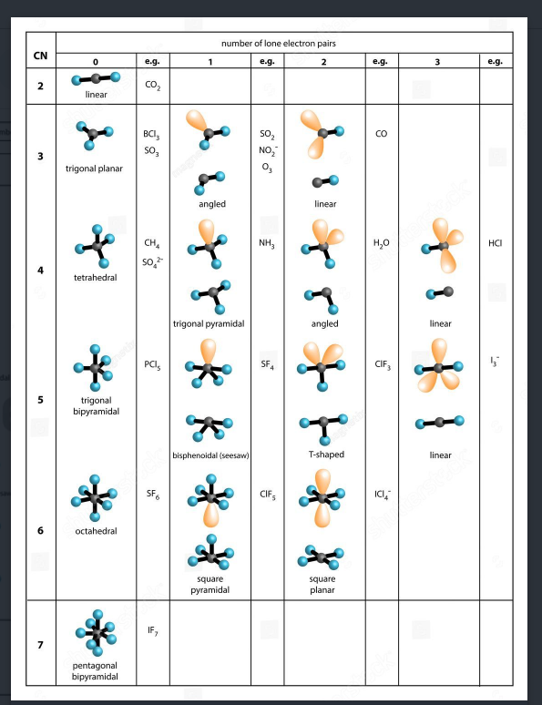

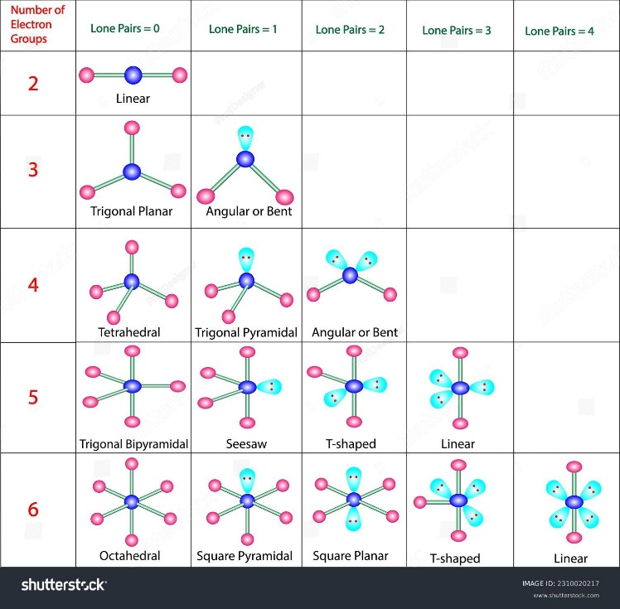

**VSEPR Molecular Shapes:** Visual representations of common molecular shapes (e.g., linear, trigonal planar, tetrahedral) based on VSEPR theory.

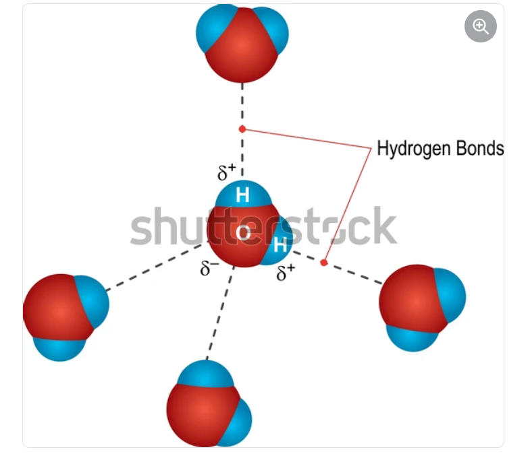

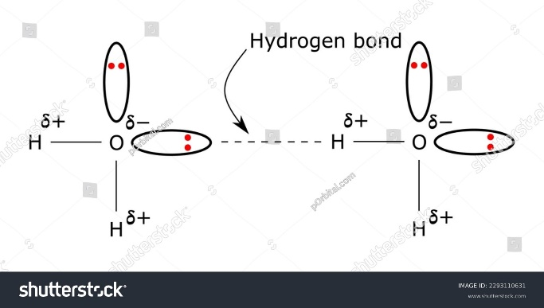

## **Hydrogen Bonding in Water:** Image illustrating hydrogen bonding between water molecules, explaining water’s high boiling point and solvent properties.

## **PSA**

## **Chapter 3: Unlocking the Atom**

**Lesson 1: The Evolution of Atomic Models and Structure**

**PSA**: Build a 3D Model

Construct a 3D model of one of the atomic structures using materials like balls and sticks or craft supplies. This will help you visualize the arrangement of particles in an atom.

**Lesson 2: Atomic Number and Mass**

**PSA:** Create a Visual Display

Design a poster or infographic that illustrates the concepts of atomic number and atomic mass. Include examples of several elements, highlighting their atomic numbers, symbols, and atomic masses.

**Lesson 3: Isotopes and Atomic Variations**

**PSA**: Explore Examples

Research common isotopes and their significance. For example, isotopes of carbon and hydrogen.

## **Chapter 4: Electrons in Action**

**Lesson 1: Electron Configuration and Quantum Numbers**

**PSA**: Visualize Electron Configurations with Orbital Models

Create a 3D model or diagram based on the "Mystery Orbital Box Challenge" activity. Present your model to the class, showing how electrons are filled to the orbitals of elements like hydrogen, helium, and lithium. Highlight the patterns and rules (Aufbau Principle, Hund’s Rule) that guided your configurations, and explain how these arrangements relate to each element’s properties.

**Lesson 2: The Electromagnetic Spectrum and Quantized Energy**

**PSA**: Explore Light with a Spectrum Display

Using observations from the activity with prisms and colored filters, prepare a demonstration or mini-exhibit on the electromagnetic spectrum. Explain the energy differences between types of radiation (e.g., infrared, ultraviolet) and how they interact with matter. Share your insights on how microwaves heat food or X-rays penetrate soft tissue, making connections to real-life applications.

**Lesson 3: The Bohr Model and Atomic Spectra**

**PSA**: Illustrate Light Emission with Atomic Spectra

Create a display of emission spectra from elements based on the activity using colored water and flashlights to explore light reflection. Highlight how the Bohr model explains specific colors produced by elements like hydrogen and sodium. Include diagrams showing electron transitions between energy levels and explaining why each element emits a unique spectrum.

## **Chapter 5: The Periodic Table and Chemical Trends**

**Lesson 1: The Development of the Periodic Table**

**PSA**: Chart the History of the Periodic Table

Design a timeline poster that traces the development of the periodic table from Mendeleev to Moseley. Include visuals and information from the salt melting test activity that links to periodic trends, showing why elements like sodium, magnesium, and calcium behave differently. Present your timeline to illustrate how these foundational discoveries influence modern chemistry.

**Lesson 2: Classifying Elements**

**PSA:** Showcase Periodic Table Classifications

Using the periodic table chart and colored markers from the activity, create a presentation on how elements are classified into metals, nonmetals, and metalloids. Discuss how electron configurations and valence electrons influence these classifications and connect your findings to real-world examples like road salt, which uses metal ions to melt ice effectively.

**Lesson 3: Periodic Trends and Predicting Properties of Elements**

**PSA:** Predict Element Behavior with Periodic Trends

## Prepare a report or presentation that illustrates how periodic trends like atomic radius, ionization energy, and electronegativity help predict element behavior. Use data from the activity where you explored trends across Period 3 to explain how elements’ positions on the periodic table reveal their reactivity and bonding tendencies.

**Chapter 6: Ionic and Metallic Bonding**

**Lesson 1: Formation and Properties of Ions**

**PSA**: Build a Model for Ions

Use materials like colored balls or clay to represent the atoms. Show how the metal atom loses electrons and becomes a positively charged cation while the non-metal atom gains those electrons and becomes a negatively charged anion.

**Lesson 2: Ionic Bonding and Compound Formation**

**PSA**: Create a Physical Model of an Ionic Compound

Select one metal and a non-metal from the periodic table. Create a physical model of an ionic compound to understand how atoms transfer electrons and form bonds. Research the properties of the compounds they formed, such as melting points, conductivity in water, or how they are used in daily life. You can present your findings in the class.

**Lesson 3: Naming and Formulas of Ionic Compounds**

**PSA**: Interactive Game

Create flashcards with the name of the ionic compound on one side and its formula on the other. Challenge your classmates to match names with formulas. This will reinforce your learning in a fun way.

**Lesson 4: Metallic Bonding and Metal Characteristics**

**PSA:** Create a Visual Display

Design a poster or infographic that illustrates the properties of metals. Include examples of common metals, their uses, and how their properties relate to their atomic structure.

**Chapter 7: Covalent Bonding**

**Lesson 1: Covalent Bonding and Molecular Structure**

**PSA:** Discover Molecular Structure

Investigate how molecular geometry is determined by the arrangement of atoms and electron pairs around a central atom. Learn about concepts like **VSEPR Theory and polar versus nonpolar molecules.**

**Lesson 2: Naming and Writing Formulas for Covalent Compounds**

**PSA:** Interactive Quiz

Create a quiz for your classmates to match names with their corresponding formulas or vice versa. This will reinforce your understanding while making it fun for everyone.

**Lesson 3: VSEPR Theory and Molecular Geometry**

**PSA**: Model Molecular Shapes with VSEPR Theory

Create a set of 3D molecular models (e.g., H₂O, CO₂, NH₃) from the activity to display molecular shapes according to VSEPR theory. Present each model, explaining how lone pairs and bonding pairs around a central atom influence shape. Highlight how understanding molecular geometry can help predict molecule behavior and interactions.

**Lesson 4: Electronegativity, Polarity, and Intermolecular Forces**

**PSA**: Explain Solubility with Intermolecular Forces

Design a comparative display using water and oil to illustrate the effects of polarity and intermolecular forces. Explain why polar molecules like water dissolve salts while nonpolar substances like oil do not. Connect this to the activity on polarity and solubility by describing how electronegativity differences lead to molecular interactions essential for everyday processes, like ice melting with road salt.